201533661 이승수’s database homework#5 date: 2016. 10. 26

**7.1 Construct an E-R diagram for a car insurance company whose customers own one or more cars each. Each car has associated with it zero to any number of recorded accidents. Each insurance policy covers one or more cars, and has one or more premium payments associated with it. Each payment is for a particular period of time, and has an associated due date, and the date when the payment was received.**

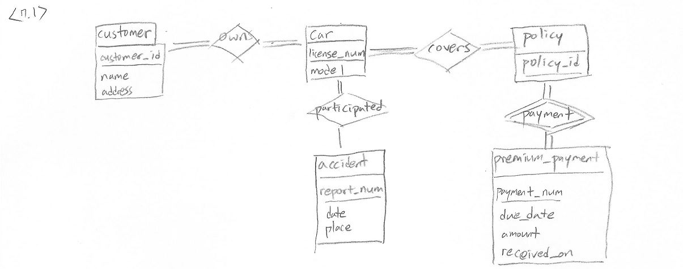

**7.3 Design an E-R diagram for keeping track of the exploits of your favorite sports team. You should store the matches played, the scores in each match, the players in each match, and individual player statistics for each match. Summary statistics should be modeled as derived attributes.**

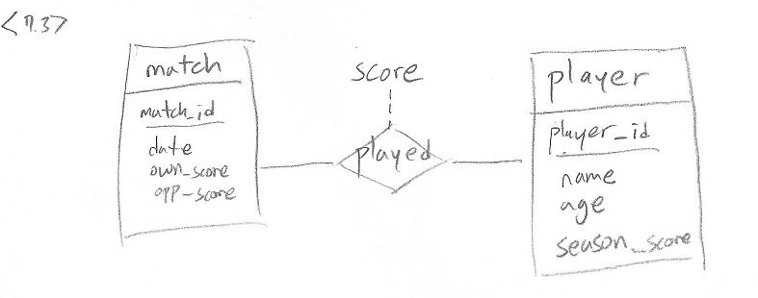

**7.8 Consider a relation such as sec course, generated from a many-to-one relationship sec course. Do the primary and foreign key constraints created on the relation enforce the many-to-one cardinality constraint? Explain why.**

In this example course relation has many-to-one cardinality constraint with student relation. Because course_id is used as foreign key at student relation’s course_id.

**7.10 Consider a many-to-one relationship R between entity sets A and B. Suppose the relation created from R is combined with the relation created from A. In SQL, attributes participating in a foreign key constraint can be null. Explain how a constraint on total participation of Ain R can be enforced using not null constraints in SQL.**

The foreign key attribute in R corresponding to primary key of B should be made not null. This ensures that no tuple of A which is not related to any entry in B under R can come in R. For example, say a is a tuple in A which has no corresponding entry in R. This means when R is combined with A, it would have foreign key attribute corresponding to B as null which is not allowed.

**7.16 Construct appropriate relation schemas for each of the E-R diagrams in Practice Exercises7.1 and 7.3.**

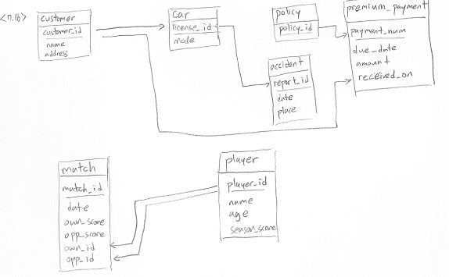

**7.17 Extend the E-R diagram of Practice Exercise 7.3 to track the same information for all teams in a league.**

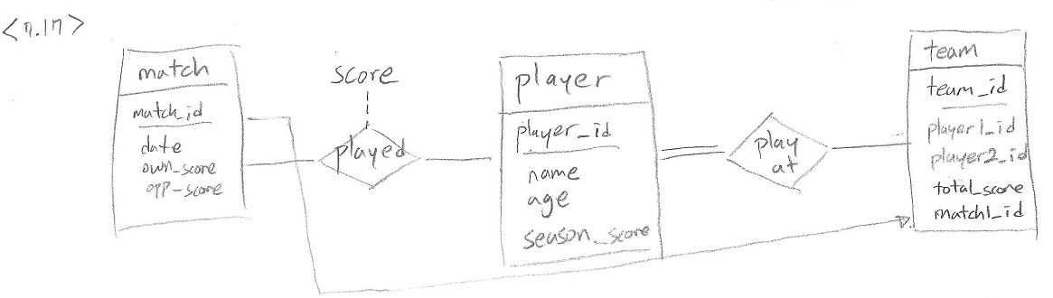

**7.21 Design a database for an automobile company to provide to its dealers to assist them in maintaining customer records and dealer inventory and to assist sales staff in ordering cars. Each vehicle is identiﬁed by a vehicle identiﬁcation number(VIN). Each individual vehicle is a particular model of a particular brand offered by the company (e.g., the XF is a model of the car brand Jaguar of Tata Motors). Each model can be offered with a variety of options, but an individual car may have only some (or none) of the available options. The database needs to store information about models, brands, and options, as well as information about individual dealers, customers, and cars. Your design should include an E-R diagram, a set of relational schemas, and a list of constraints, including primary-key and foreign-key constraints.**

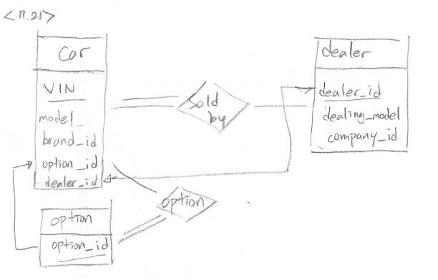

**7.22 Design a database for a world-wide package delivery company (e.g., DHL or FedEX). The database must be able to keep track of customers(who ship items) and customers (who receive items); some customers may do both. Each package must be identiﬁable and trackable, so the database must be able to store the location of the package and its history of locations. Locations include trucks, planes, airports, and warehouses. Your design should include an E-R diagram, a set of relational schemas, and a list of constraints, including primary-key and foreign-key constraints.**

